HTTP Repository Server Setup

1. Install HTTP

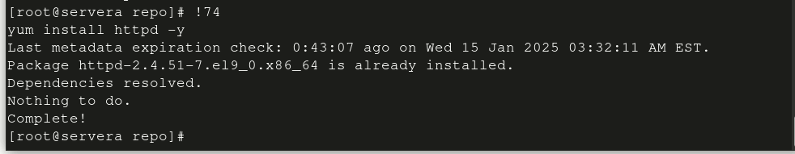

1. Create directories /var/www/html/repo

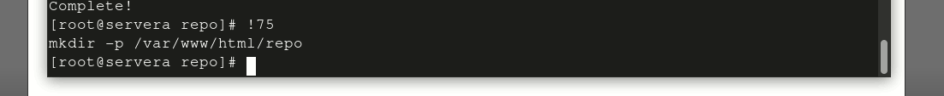

1. Change ownership to apache for the directories recursively



1. Change permissions to 755 i.e full persmission to user and read and execute to group and others



1. Install repo



1. Enter into the directory /var/www/html/repo



1. Create repo at present working directory

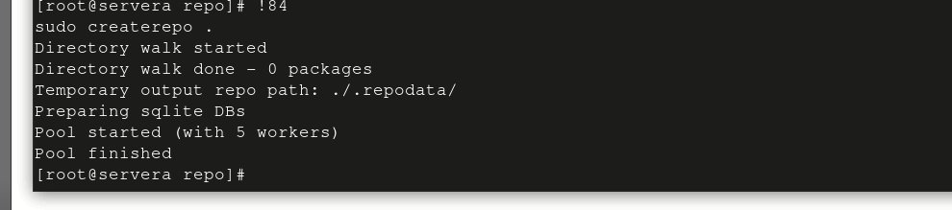

1. Edit the httpd file vim /etc/httpd/conf.d/repo.conf

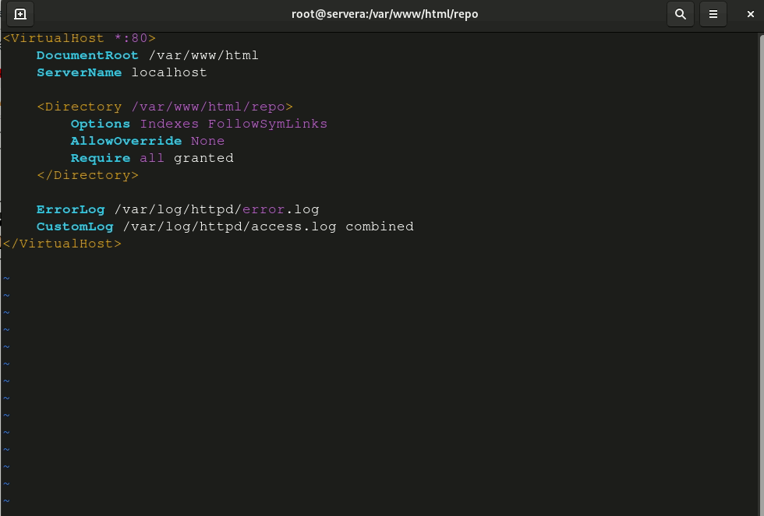



1. Enable HTTP



1. Start HTTP



1. Add service in firewalld





1. Search the IP server at firefox to verify the result

